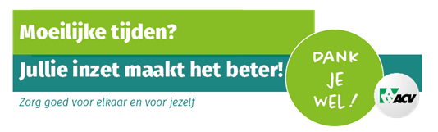
ACV-CSC-METEA: Campaign “Re-member” Belgium

What is/was the aim in the campaign?
Our Re-member campaign is part of a large-scale member campaign run by the confederation, in which every regional federation and sectoral union is involved. This means that certain aspects of the campaign will not be run by our sectoral union, but by the confederation.
- The main objectives of the campaign are:
  - A systematic and broad project of member recruitment, retention and member care (supported by both militants and staff).
  - Attention must be paid to specific target groups (such as young workers, SME workers …)

What has your organisation done to achieve the aim?
- A series of trainings aimed at both staff members and militants:
  - What enables someone to believe in and push the campaign forward? He/she has to be proud of his/her organisation first.
  - Why are members so important? (Why recruit them? Why keep them “on board”? Why convince them to come back once they’ve “jumped ship”?)
  - What can I do to contribute to this campaign from my own position?
- Specific, target group-oriented campaigns:
  - Hello new life (female workers)
  - Union match (young workers)
  - Other target groups, e.g. SME workers, in conjunction with the confederation and the regional federations.
- A more general campaign: to improve and promote Ekivita (= commercial benefits for members, e.g. discounts in shops, holiday centres …)
What (communication) tools have you used to reach the target group?
- Training (see above).
- Putting together a toolbox per company (= an analysis of the membership rates, compared with the overall number of workers in said company: searching for so-called “blind spots” and trying to determine a target group-oriented approach).
- METEA Magazine (militant magazine).
- Facebook
- Specific tool used by the confederation: contacting members who are behind in paying their membership fees by phone

What risks are you facing and what are possible solutions?
Risk: Paying too much attention to the influx of new members, whilst not doing anything about the outflow of members.
Solution: A staged mailing campaign, targeting all new members:

    - Stage 1: making sure we can confirm as quickly as possible that the unemployment file of the members at hand has been taken care of and that their unemployment benefits have been paid.
    - Stage 2: what else does our trade union do to make sure the well-being of all workers is taken care of? Specific focus on health and safety measures.
    - Stage 3: ideological arguments + appealing to their solidarity, singling out the other realisations of our trade unions (e.g. social security etc.).

What recommendations do you have for others?
Don’t focus solely on recruiting new members. Make sure people want to remain member of your trade union. Take care of the members you’ve already got!
Make sure everybody supports your actions, staff included. If your staff is not motivated to make the campaign work, it is never going to get off the ground.
What is the result of the campaign (so far)?
Over the past few months – especially following the coronavirus outbreak – we’ve witnessed a net increase in our number of members. 1 out of 4 decided to remain member of our trade union thanks to said phone call.

We will keep the membership focus!

